**Second Increment Report:**

**Team Members:**

Sidrah Junaid.

Yeruva, Vijaya Kumari

Saria Goudarzvand

**Project Overview:**

The objective of the project is to develop an application that predict the eating habits, mood and activities of the user based on his/her Twitter activities. For accomplishing the objective Twitter API is used.

**Significance:**

The significance of the application is that the user can keep track of his/her lifestyle whether it is healthy or unhealthy and the activities of interest. It also helps user to find the people having similar interest and choices.

**Existing Services/REST API:**

Twitter APIs is used to collect tweets to implement increment2

**Implementation:**

For increment 2, we have gathered sufficient data for training and applied topical clustering with respect of food, activities and emotions. The data is further classified into Food (healthy, unhealthy),Activities(Active, Passive),Emotions(Happy ,Sad) and labels are assigned to that data. Along with that we created an interface of an android app through which we can accept user input.

Source Code: <https://github.com/VIJAYAYERUVA/BestBuddy/tree/master/Sourcecode/BestBuddy>

**Project Management:**

Work completed:

1. We have created the training data using Twitter tweets

2. Implemented user interface of our application using android studio

3. Deployed that application to Android mobile and Emulator

**Details of Increment 2:**

Below is the screenshot of collected tweets.

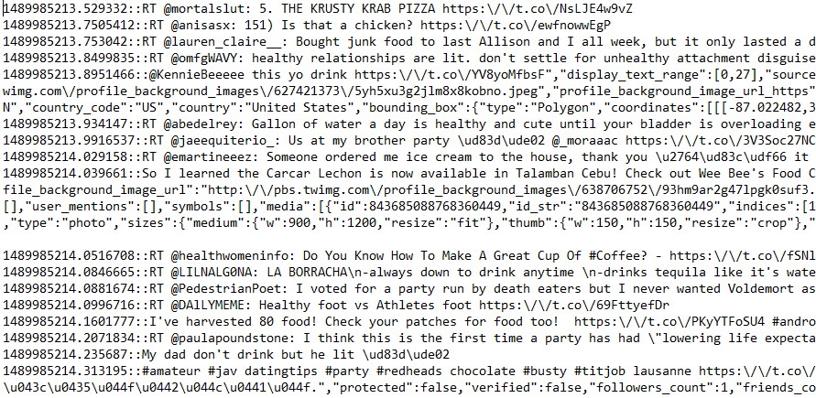

Pre-Processed Data:

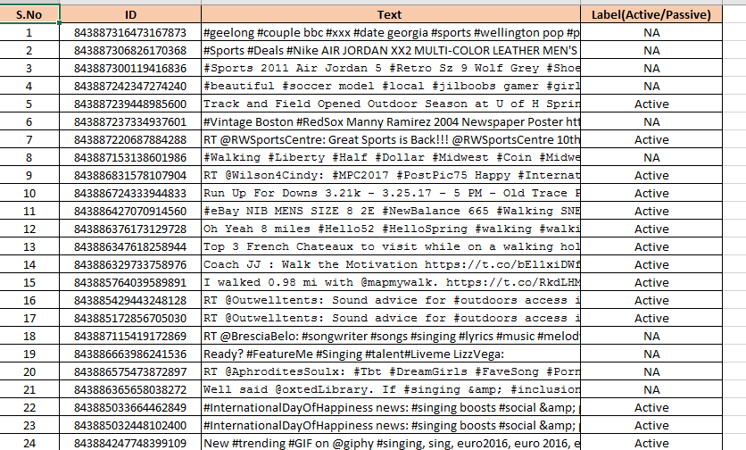

**Project Responsibilities**:

1.Tweets collection Saria(Emotion),Vijaya(Activities),Sidrah(Food)

2.Cleaning Tweets Saria(Emotion),Vijaya(Activities),Sidrah(Food)

3.Training data classification and labelling Saria(Emotion),Vijaya(Activities),Sidrah(Food)

**Bibliography:**

<https://www.youtube.com/watch?v=nzkrRQgCEmE>

<https://www.android.com/>

<https://dev.twitter.com/rest/collections>